**LOGISTICS DATABASE**

**Table 1 : Employee_Details**

* create table Employee_Details(Emp_ID int(5) primary key, Emp_name varchar(30),

Emp_Branch varchar(15),Emp_Designation varchar(40),Emp_Addr varchar(100),

Emp_Cont_No varchar(10));

* describe Employee_Details;

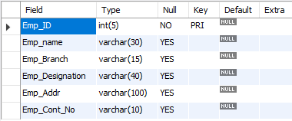

* select * from Employee_Details;

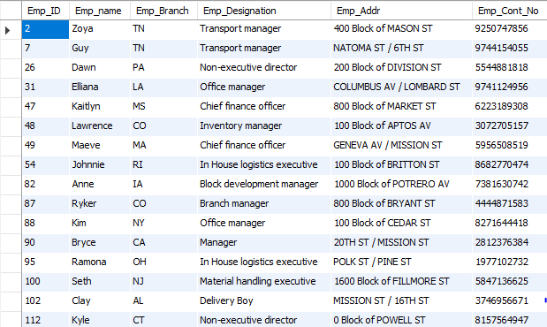

**Table 2 : Membership**

* create table Membership(M_ID int primary key, START_DATE Text, END_DATE Text);
* describe Membership;

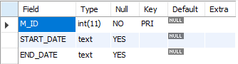

* select * from Membership;

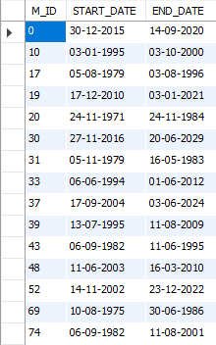

**Table 3 : Customer**

* create table Customer(Cust_ID int(4) primary key, Cust_Name varchar(30), Cust_Email_ID varchar(50) , Cust_Cont_No varchar(10), Cust_Addr varchar(100),Cust_Type varchar(30), Membership_M_ID int , foreign key (Membership_M_ID) references Membership(M_ID));
* describe Customer;

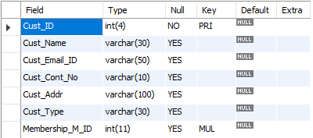

* select * from Customer;

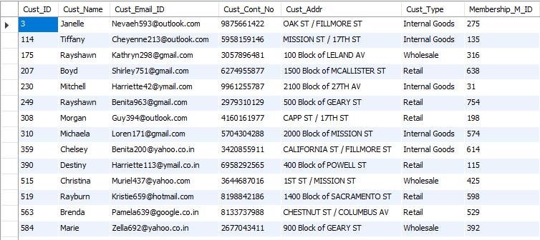

**Table 4 : Payment_Details**

* create table Payment_Details(Payment_ID varchar(40) primary key, Amount int, Payment_Status varchar(10), Payment_Date text, Payment_Mode varchar(25), Shipment_sh_ID varchar(6), foreign key(Shipment_sh_ID) references Shipment_Details(SD_ID), Shipment_Client_C_ID int(4), foreign key (Shipment_Client_C_ID) references Customer(Cust_ID));
* describe Payment_Details;

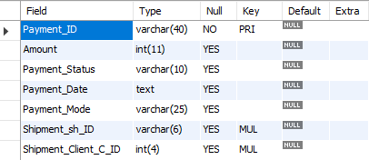

* select * from Payment_Details;

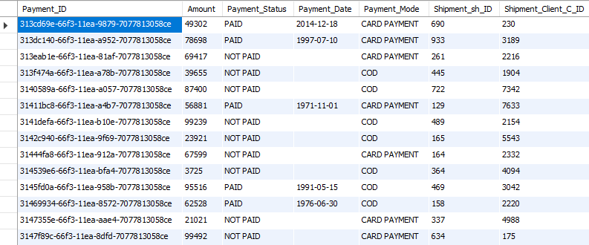

**Table 5 : Shipment_Details**

* create table Shipment_Details(SD_ID varchar(6) primary key, SD_Content varchar(40), SD_Domain varchar(15), SD_Type varchar(15), SD_Weight varchar(10), SD_Charges int(10), SD_Addr varchar(100), DS_Addr varchar(100), Customer_Cust_ID int(4), foreign key(Customer_Cust_ID) references Customer(Cust_ID));
* describe Shipment_Details;

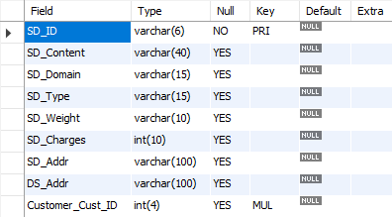

* select * from Shipment_Details;

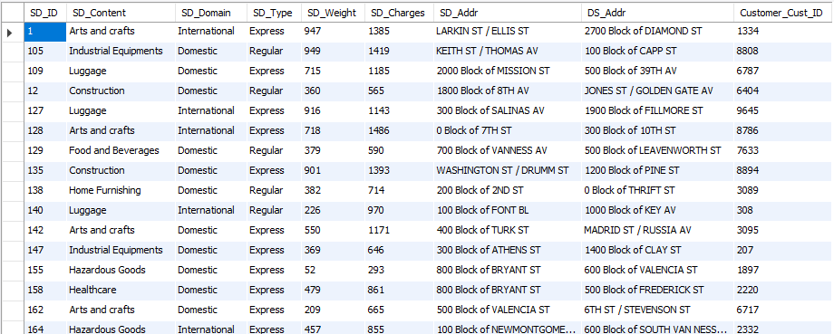

**Table 6 : Status1**

* create table Status1(Current_ST varchar(15), Sent_Date text, Delivery_Date text, SH_ID varchar(6) primary key);
* describe status1;

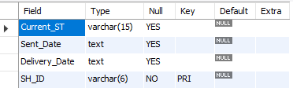

* select * from status1;

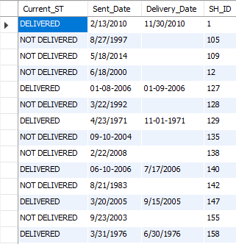

**Table 7 : Employee_Manages_Shipment**

* create table Employee_Manages_Shipment( Employee_E_ID int(5), foreign key(Employee_E_ID) references Employee_Details(Emp_ID), Shipment_SH_ID varchar(6), foreign key(Shipment_SH_ID) references Shipment_Details(SD_ID), Status_SH_ID varchar(6), foreign key(Status_SH_ID) references status1(SH_ID));
* describe Employee_Manages_Shipment;

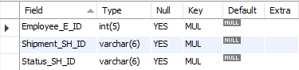

* select * from Employee_Manages_Shipment;

